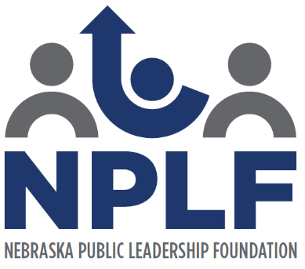

Scholarship Application
(Please note this is a non-renewable scholarship.)

This $1,000 Scholarship will be awarded to:

- A Nebraska senior in high school with plans to attend a college or university in Nebraska.

- A Nebraska senior in high school with an interest in the area of becoming an educator.

- A Nebraska senior whose school district is a member of the Nebraska Association of School Boards.

Please include the following:

- Two letters of recommendation from educators.

- Your unofficial high school transcript. (minimum of 3.0 GPA)

- A list of your accomplishments.

1. | First Name: | Last Name:
2. | Mailing Address::  Street:  City: State: Zip:
3. | Phone Number:
4. | Email Address:
5. | High School Currently Attending:
6. | College Attending Fall of 2024:

7. | College Major:
8. | What or who in your family has inspired you to become an educator?
9. | What are your educational and professional goals and objectives?
10. | Personal Essay (500 words maximum)  Please answer the following question. You may use a separate page to complete your answer.  Why do you want to be an educator and how have you shown public leadership?

Signature of Scholarship Applicant: _______________________________________ Date: _____________________
(By signing this form, you certify that all of the information provided in this application is accurate and complete to the best of your knowledge. You also understand that any false or misleading information may result in disqualification from the Nebraska Public Leadership Scholarship.)

Please fill out the application and mail by March 1st to:

Sallie Horky
Nebraska Public Leadership Foundation
1311 Stockwell Street
Lincoln, NE 68502
Or
Email: shorky@nasbonline.org

